**LIU Kang (1911-2004)**

Liu Kang is thought of as a founder of Singaporean modern art. However, he was born and educated in China, and moved to Singapore in 1937 at a time when the island was still part of the British Empire. His art was therefore never about Singapore in a straightforward sense. Rather, his historical significance lies in creating in Singapore a kind of Chinese-inflected modern painting combining together European modernism, traditional Chinese painting and the folk cultures of Nanyang, a Chinese term referring to the area south of China reachable by sea-vessels. After Liu arrived in Singapore, he became part of a group of Chinese painters and writers who had produced creative works centered on Nanyang since at least the early 20th-century. Using the modernised Chinese painting of his formative years, he expanded its iconography to include the landscapes and peoples of Nanyang, producing some of the best-known works of his oeuvre. These include *Chopping Firewood* (1956), *Outdoor Painting* (1954) and *Artist and Model* (1954). Creating a syncretic painting with elements from the three cultures became the artist’s *modus operandi* that remained largely unchanged for the rest of his career.

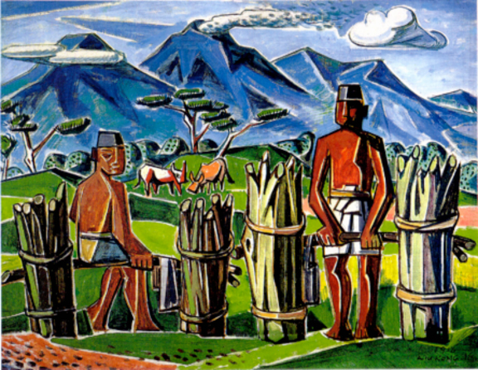

LIU Kang, *Gathering Firewood*, 1956, oil on canvas, 102 x 80 cm, Collection of Liu Family (Please send request to: Miss Liu, 20 Jalan Sedap, Singapore 438276)

Born in Yongchun province, Liu moved to Malaya as a child, and in 1926 went to study in Shanghai. He enrolled at the Shanghai Academy of Art, and became life-long friends with its founder and principal, Liu Haisu (1896-1994), a figure who played a significant role in shaping his aesthetic preferences. During his time in Shanghai, China was reforming its political and cultural institutions, including ones related to the arts. Many intellectuals believed that traditional ink painting was no longer relevant and a new art was needed, preferably one that borrowed from Western art. There was, however, no consensus. Some believed that Western art should replace ink painting, while others, including Liu Kang and Liu Haisu, thought that traditional painting should be modernised by infusing it with elements from European modernist painting. Amalgamating Chinese and Western aesthetics was to become a key component of Liu’s oeuvre.

Between 1929 and 1933, Liu went to study art in Europe, travelling through the region, viewing and creating artworks, often in Liu Haisu’s company. As a result his works tended to have a vivid palette, bold outlines and loose brushwork, but for him these formal devices were not entirely Western: he believed that their development came about partly through contact between European artists and East Asian paintings. From 1933 to 1937, when Liu returned to Shanghai to take up a teaching position at his alma mater, he also experimented with producing Chinese calligraphic brushstrokes with oil paint, creating what could be described as a modernised Chinese painting. Examples of such works include *Inner Lake in Hangzhou* (1936) and *White and Red Wall* (1935).

Liu left China after the Sino-Japanese war broke out, settling in Singapore at the end of WWII. He lived there until the end of his life, painting and exhibiting actively.

**References and further reading**

Andrews, J. and Shen, K. eds (1998). *A Century in Crisis: Modernity and tradition in the art of twentieth-century China*. New York: Guggenheim Museums Publication.

Liu, K (2011). *Essays on Art and Culture*, ed. Sara Siew. Singapore: The National Art Gallery, Singapore

Mashadi, A (2006). ‘Nanyang Modernism: Between idealisms.’ in Y Fumichi and Aki H, eds. *International Symposium 2005: “Cubism in Asia: Unbounded dialogues.” report*. Tokyo: Japan Foundation.